PROJECT MANAGEMENT IN THE CREATIVE INDUSTRIES
Margarita Ruseva
Abstract: Access to finance for the creative industries can be difficult, mainly due to the intangible nature of their assets and collateral, the limited scale of the market, the uncertainty of demand and the lack of expertise on the part of financial intermediaries, taking into account the specificities of the creative industry. Every organization should know the "life cycle of the project". It represents a sequence of phases (stages) in the development of the project from its beginning to its end. Splitting the phase design allows for better and more efficient implementation and management.
The aim of this article is to analyze, through in-depth analysis, the difficulties associated with the development, implementation and management of projects by the creative industries. These gaps in the skills of art managers were found after a survey based on an in-depth interview in the city of Plovdiv, Bulgaria. This article reflects the results of the empirical study. The survey was conducted among 105 organizations and their managers working in the field of creative and recreational industries and identified gaps in project management, resource management, people, and risk assessment. Risk management is an element of the financial management of any organization, including art organizations. Good risk management is a guarantee for success and the achievement of the goals of art organizations. The environment in which the art develops is dynamic, provocative, and it requires an up-to-date risk assessment, which in turn is a requirement for knowing the stages, methods and mechanisms of risk reduction to dimensions that will give reasonable assurance to the organization's art management that the goals will be achieved.
JEL Classification Numbers: M21, O22, Z11, DOI: 10.12955/cbup.v7.1372
Keywords: creative industry, project, development, management

Introduction
In the current conditions of strong differentiation of the regions in terms of economic development, the main factors for growth are not labour and production activity, neither information nor knowledge, but creativity as the ability to create something new. Creative industries are one of the fastest growing sectors of the economy. Exploring the role of this industry for the development of the economy becomes particularly important after the global financial crisis, the implications of which necessitate a revision of the existing strategic guidelines of regional planning and the formation of new development models. An increasing number of studies confirm that creative industries contribute greatly to the export potential of countries and regions, and that their market share is growing faster than other sectors of the economy. The socio-cultural environment has a specific impact on the development of regional systems whose quality solves a number of socio-cultural problems: it increases the attractiveness of the region for cultural tourism, creates jobs, and encourages the development of the so-called regions at risk. In connection with the above, it is extremely important to develop a methodology and a general mechanism to ensure the development of a socio-cultural environment in the region, consistent with the contemporary realities of market relations and trends in the development of culture and society. It is important to understand that cultural resources, like any other resource, under certain conditions can bring "profit". In this regard, cultural resources need a certain environment that contributes to the development of creative forces and brings economic value (Falk and Dierking, 2008). With the development of these trends, governments from different countries as well as private and corporate investors are interested in the prospects of creating tools to assess the contribution of culture to the development of the economy.
Over the last decades, the terms of "post-industrial society", "knowledge economy", "creative economy" and "creative industries" received special attention from the scientific community and practice. Researchers unanimously believe that the future of the modern economy is behind small and medium-sized enterprises that produce innovative and environmentally friendly products and services. Since the 1980s, culture has been seen as a resource for development processes and community self-identification, the importance of cultural resources in economic processes and in the development of territories has been noticed (Schemerhorn, 1986). Moreover, culture is becoming an instrument for achieving the socio-economic goals of countries and regions. There is a transformation of the commodity economy and an increase in the priority of the so-called creative economy (Hesmondhalgh, 2002).
Cultural and creative industries also need people who have business skills (for example, in the field of management, trade skills, etc.). They must have knowledge and be able to use specific financing tools (banks and financial institutions, sponsorships and donations, etc.), and to know the new technologies (Byrnes, 2008).
The aim of the proposed study is to analyze thoroughly the management features of art organizations in the creative industry sector in the city of Plovdiv, while at the same time identifying the difficulties related to their financial management, control and realization of projects.
The object of the study are art organizations, registered in the city of Plovdiv, and the subject of the present work is the management profile of the art organizations, which includes project management.
The research thesis finds the basis in the opinion that managers of part of the art organizations do not have enough theoretical knowledge and experience to implement projects. Managers experience difficulties in projects’ development and implementation (Dvir et al., 2003). This deprives them of the opportunity to apply for national and European programmes, to manage their organizations effectively and efficiently. By enhancing their management skills, managers will improve the performance of their products or accelerate the development of their business, and to the entrepreneurs working in the field it will provide a foundation for development. It is therefore necessary to upgrade the theoretical and practical skills of art organization managers, both in project management and in financial management and control.
The research thesis presented here provides a basis for formulating the complementary research hypothesis: leaders in the cultural and creative industries need additional support related to project finance and financial management.
The research focuses on the realization and the opportunities of the art organizations for project development and management.
Data and methodology
The creative potential of the regional socio-economic system is the ability of this system to develop creative industries based on generating ideas for enhancing the competitiveness of the regional economy. A favourable environment for the structuring of creative industries is the cultural, political and economic conditions created by the region, the availability of a number of authors of creative ideas, the demand for a creative product among the population, and areas of interaction. Creative industries contribute to the revival of regional economies and can become a source of growth for regional development by forming a special socio-cultural environment, maintaining the uniqueness of the region. They provide the demand for creative potential by creating new jobs, creating a favourable image and branding of the territory by creating an appropriate infrastructure (Barkalova and Kazashka, 2010).
Creative industries combine business skills and cultural practices based on an intellectual component. From the point of view of the forms of business, the creative industries are mostly small enterprises, rarely medium-sized enterprises. At the same time, these are local industries that seek to gain access to world markets in the post-industrial economy - Kolev, V. (2017). The cultural and creative industries are a highly innovative component with significant potential for capital formation, opening new jobs through the creation and use of intellectual property. The development of the cultural and creative industries and the creation of partner networks in this field is an up-to-date and vital goal of contemporary social and cultural space. The search for opportunities to implement creative potential and the creation of innovative business models that contribute to cultural projects is one of the most important perspectives of regional development (Ivanova, 2017).
The labour market requires employees with a new profile - managers who have good professional expertise in the field in which they work but who are also economically trained - have management skills, communication skills - effectively communicate with partners and employees, manage time, people and processes, know and use project funding as a tool to attract additional funds.
A number of studies have shown that cultural industries are a dynamic sector that has a major impact on economic development in the general case of Europe and Bulgaria and in the narrow sense – of the city of Plovdiv. The effect of the activities developed by the cultural industries is a multifaceted key mechanism that includes:
1) Economic effect, expressed in the provision of employment for the people, profits, encouragement of innovation, and introduction of new technologies.
2) Social effect, the result of which is to promote creativity.
3) Cultural effect, expressed through the promotion of cultural diversity, the preservation of cultural and national identity, the satisfaction of people involved in cultural industries (Pick, 1986).
The funding opportunities for these organizations are diverse - national and international, state and private, but the overall role is generally assigned to the state. Funding should be in line, on the one hand, with the legislation that corresponds to the European legislation and strictly individual, tailored to national cultural specificities and, on the other hand, with the state as a source of funding through a budget subsidy or a guarantee for European programs.
The toolkit is developed on a concept, conceptual apparatus and indicators, compactly structured in an information map for an in-depth expert interview. Registration of empirical data was performed using an electronic platform (https://fisn.uni-plovdiv.bg/survey/index.php?sid=15228&lang=bg).
The empirical study was conducted between March 07, 2017 - July 20, 2018, and includes observations, preparation and completion of a standardized questionnaire and conducting semi-standard interviews with representatives of the creative and recreational industries in Plovdiv.
Of a total of 272 questionnaires sent in electronic form to the managers of the creative and recreational industries on the territory of the city of Plovdiv, a total of 120 completed questionnaires with 99% response rates were received. After validation, due to inaccurate and missed answers, 105 questionnaires were submitted to the analysis.
The processing of the recorded data was done through a specialized software product for social research IBM SPSS, version 25.0 and MS Excel 2018. The analysis of the data uses an analytical approach based on the decomposition of the object of the study to its components through the analysis and generalization of the obtained characteristics and conclusions in the course of synthesis.
Results and Discussion
In order to evaluate the success of the projects of organizations working in the field of creative and recreational industries, a question has been formulated giving information about successfully implemented projects over the last five years.
Figure 1: Successfully implemented projects over the past five calendar years
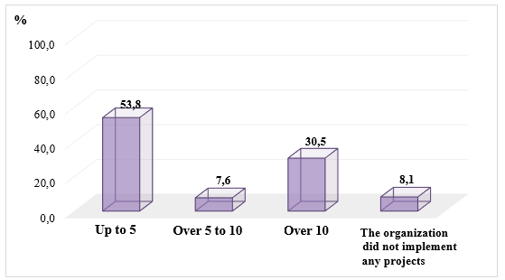
Source: Author
53.8% of the art organizations indicated the answer "up to 5 projects", while 30.5% of them have won and successfully implemented more than 10 projects over the last five calendar years. Between 5 and 10 projects were implemented by 7.6% of the creative industries in the city of Plovdiv for the indicated time period. From the results obtained, it is clear that 8.1% of the art organizations failed to implement any of the prepared and submitted project proposals (Figure 1).
Access to funding of art organizations in these sectors may be difficult, mainly due to the intangible nature of their assets and collateral, the limited scale of the market, the uncertainty of demand and the lack of expertise on the part of financial intermediaries, in considering the specificities of the creative industries.
Interest in the present study is also the possibility of funding the cultural organizations through project activity, using national and complementing through international financing instruments. At national level, the main funding is that from the budget and through the Culture Fund, while the Creative Europe programme is the main European financial mechanism (Kazashka, 2017, Kolev, 2018). Creative Europe is the only direct programme for the creative and cultural sectors and it has strengthened its role in this respect - in continuity with previous programmes and especially with the tradition of exchange and dialogue in the community of artists and cultural institutions of the Member States.
From the summarized results it is clear that the majority of the implemented projects are financed by other sources (with foreign funds). The relative share of these projects represents 39% of all implemented project proposals by the art organizations in the city of Plovdiv. The Ministry of Culture provided funding for 22.6% of the implemented projects, and 15.1% of the funds were provided by business organizations. Only 7.5% of the implemented projects are funded with funds from the European funds, which means that virtually art organizations do not use their potential sufficiently.
Access to funding is the main obstacle to growth for many businesses in the sector. As mentioned, many entrepreneurs in the field of culture and creativity work as small or medium-sized enterprises. Among them, companies with one or two employees make up the vast majority of enterprises in the sector, including the new "entrepreneurial citizens" or "entrepreneurs in the field of culture" that no longer fit into the typical concept of full-time jobs and professions.
For various reasons, the creative industries face particular problems in terms of achieving investment readiness: lack of information and understanding of appropriate sources of funding, difficulties in developing a business plan and its convincing presentation, or reliance on a wrong business model.
In addition, for the most part, this type of business is typically based on a prototype or a specific project and depends to a large extent on the success of its leading products or services and the individual talent and the ability to take risks.
The access of art organizations to financial support is limited, as many enterprises suffer from capital shortages and, when seeking financing, they face serious problems in obtaining a fair valuation of their intangible assets, such as copyrights. Unlike technology companies, the intangible assets of the creative industries have no recognized value in their balance sheets, and their investments in the development of new talents and creative ideas are not fully in line with what is normally implied in the concept of research and development.
Investors and banks' awareness of the economic value and potential of art organizations needs to be improved. Investments should be encouraged through the use of guarantee schemes and other financial engineering mechanisms.
In the context described, innovative financial instruments, such as venture capital and guarantees, as well as other risk-sharing instruments offered by market participants, can play an important role in facilitating access to finance for small and medium-sized enterprises. Such instruments are used in the context of market-oriented EU spending programs (e.g. the Competitiveness and Innovation Program). These tools have proven to be effective in helping small and medium-sized enterprises to gain access to finance but target a variety of businesses and do not necessarily refer to creative industries.
At national and regional level new funding models are emerging for art organizations. Some of them facilitate access to loans by pooling expertise across sectors to assess businesses and their projects. Others create contacts between investors and businesses in need of venture capital for their growth. From the results obtained, it is seen that the creative industries sector needs investor support. This requires the creation of a package of investment proposals in certain areas as well as investments by regional and municipal authorities.
To create such an investment program, more in-depth and more targeted research is needed in the field of creative industries, marketing and economics of culture.
The majority of the projects implemented by the creative industries in the city of Plovdiv are projects in the field of performing arts (52.3%). It is particularly important to note that art organizations have successfully implemented projects that link culture, art and education (22.9% of all projects) during that period. 14.3% of the projects have a thematic focus on the field of modern visual arts. Successful project proposals in the field of cultural and historical heritage account for 8.6% of the approved and implemented projects in the city of Plovdiv. The smallest is the value of the relative share of projects related to cultural periodicals and scientific research (Figure 2).
Figure 2: Types of projects implemented by the creative industries in the city of Plovdiv
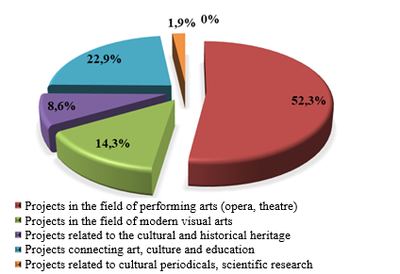
Source: Author
The interviewed experts agreed that the creative industries are interesting and significant in the process of building partnerships with other organizations. It is important to bear in mind that the nature of such relationships implies mutual benefits for the participants and the active participation of the parties in future joint initiatives.
According to the obtained data summarized, 63.9% of the implemented art projects are worth up to 25,000 euros, meaning that the majority of successful projects are small, thus the organizations in the creative industries cannot fully exploit their potential for work within the project activity. 30.5% of the art organizations in the city of Plovdiv have implemented projects worth "over 25,000 euros up to 50,000 euros" and only 5,6% of the implemented projects are worth over 50,000 euros.
The next question from the in-depth interview gives information about whether the art organizations have difficulties in project management. More than one third of managers said they were experiencing difficulties in project management (36.2%). The majority of respondents believe that they have no difficulties in managing the winning projects - 63.8%. Among the indicated difficulties is the management of time; cost management; human resources management, communications management, and risk management. Each art organization needs to know the "project lifecycle". The division of the project into phases allows for better and more effective implementation and management. Each phase of the project ends with the achievement of one or more results.
Moving from one phase to another is related to the transfer of knowledge, technology or results. Each phase is based on the results achieved in the previous phases. In the initial phases, costs are usually low, the project team is smaller, and the risks are greater. Approaching the end of the project, spending increases, while uncertainty about the achievement of the goals set decreases.
The next two questions in the information card aim to identify the difficulties in managing and implementing projects in the two important stages of its life cycle, namely: the "initiation" stage and the "planning" stage.
The most common difficulties encountered by cultural organizations are at the stage of initiation. Among the main difficulties of the creative industries when initiating the project is the identification of the main goal and sub-goal. This possibility is indicated by 41.7% of the experts. For 33.3% of them, the determination and assessment of the organization's internal resources is a major difficulty in initiating the project. According to 25% of the experts who participated in the study, the main difficulties are related to the definition of the project activities (Figure 3).
Some of the obstacles at the planning stage are: (1) determining the resources needed to implement the activities (33.7%); (2) determining quality management indicators (28.5%) and (3) drafting of the project budget (19.2%). Relatively fewer difficulties are encountered by managers when determining the time for implementation of the activities and the preparation of the plan (9.5%), as well as in determining and assessing the risks (9.1%) - Figure 3.
Figure 3: Difficulties encountered by the creative industries at the project's "initiation" stage
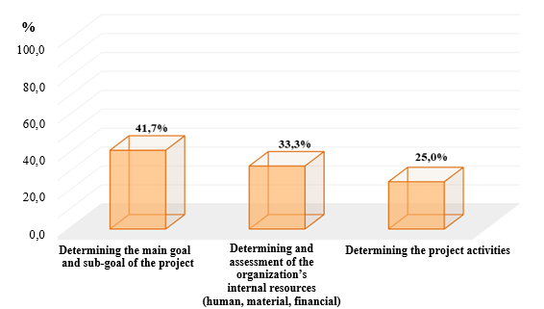
Source: Author
In order to overcome these difficulties, a careful and detailed analysis needs to be made, involving all the organizations that will implement the project. A logical framework is used in the planning process to ensure consistency between objectives, activities and results, and to carefully assess all risks in the project.
Figure 4: Difficulties encountered by the creative industries at the planning stage of the project
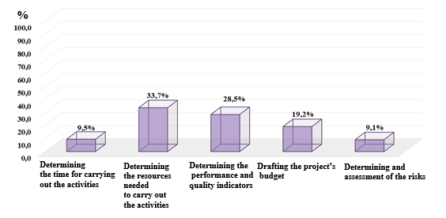
Source: Author
The recommended sequence of planning the activities, defining the resources, setting the time, and budgeting is applied. Different approaches, proven by practice, are applied, the critical path is analysed when planning the time schedule, the project resources are optimized, the interests of the interested parties are being balanced, i.e. of the financing organization, the user of the result, and the participants in the project.
One of the most effective project management tools applicable to the cultural sphere projects is the project structuring model (Fayol, 1949). Of the large number of applied project structuring models as most suitable for art organizations can be: (1) the tree of goals, decisions and activities; (2) the matrix of responsibilities; (3) the structure of expenditure and the structure of resources spent; and (4) a network model. Besides their optimal integration into the network model, the selected models are flexible, convenient, accessible and do not require additional training. Each of these project structuring methods can easily be adapted to management in the fields of culture and arts. The specificity of each model is almost identical to its advantages and can be formulated as follows:
- The tree of goals, decisions, activities. These methods represent hierarchical structures formed by dividing the overall goal (decision, activity) into sub-goals (tasks, decisions, activities), which in turn become more detailed components (new sub-goals, sub-decisions, functions, etc.).
- The Matrix of Responsibility defines the roles, the level of responsibility, and the authority of each team member in the performance of the art project, thus balancing the activities of each of them. In this case, the number of levels of responsibility depends on the specifics of the project.
- The structure of expenditures and the structure of spent resources provide a rational ratio of different cost elements in their total amount, and determine the value of project activities at each level.
- The network model is the graphical presentation of the project. It explains the connection between the different activities and the sequence of their execution, which allows to optimize the time for project implementation.
Figure 5: Advantages of art and creative industries for the success if each particular project
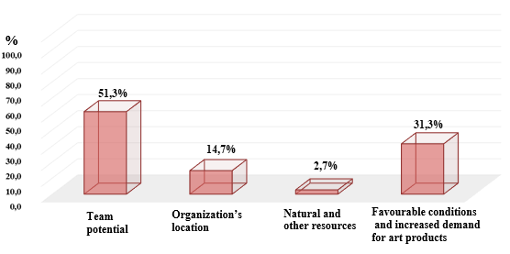
Source: Author
The presented project structuring methods are an integral part of the overall planning process. Their use significantly reduces the risk of each art project and contributes to improving its quality.
For the majority of managers, the advantages of the art organizations for implementing a project lie in the potential of the team. This opportunity was indicated by 51.3% of the survey participants.
According to 31.3% of the managers, the advantages of the organizations are explained by the favourable conditions and the increased demand for the art products. The location of the organization is mentioned as an opportunity by 14.7% of managers. In the process of implementation of the projects the contribution of natural resources and other resources is the smallest - (2.7%) - Figure 30.
The summarized results regarding the implementation of the specific methodology for project development and management are extremely interesting. This is because the majority of art organizations have indicated that they do not use a specific methodology for project development and management but only act on the instructions of the competition (55.3%). However, 44.7% of the managers of the organizations have given an affirmative answer to this question. Some of them (21.9%) rely on colleagues from other art organizations and use this methodology, which is recommended by them. 22.8% of the creative industry organizations in the city of Plovdiv in the processes of project development and management implement a methodology that has been proposed by consultants.
To the question, "Do you need to get acquainted with specific project management methodologies?" the managers of art organizations think it is very useful to enrich their theoretical knowledge and experience with others like them. They are of the opinion that it is necessary to constantly update and make available the methodologies of the individual organizations, as this will help to more effectively work in the project management process. They believe it is always useful to learn about the novelties and specifics of each funding institution. In this case, the nature of each project must be taken into account. Here, it is important to note that art organizations mostly need a methodology to develop projects linking art, culture, education and European cultural cooperation. On the one hand, project managers in cultural organizations believe that they need a methodology when developing the financial framework of project proposals. On the other hand, managers say that, unfortunately, no project management methodology, especially in the field of visual arts, is not effective enough because it has to be tailored to the specific characteristics of these arts.
On the basis of the opinions received from the experts as key aspects of the interaction between art organizations for the implementation of joint project proposals, the following can be outlined:
- interdisciplinarity and expansion of the interaction formats, as it is necessary to respond to new consumer preferences;
- pool resources, attract partners to perform specific tasks for which art organizations lack their own resources or competencies;
- the need to expand and improve competencies in project management and, in this respect, the implementation of marketing and management education programs, the development of algorithms and mechanisms for the implementation of certain tasks and projects (fundraising, volunteer work and others.).
The effectiveness of this interaction depends on various factors that can have both positive and negative influence in the process of interaction between art organizations. The two most important groups of factors can be structured in the following way:
First: lack of understanding of the need for cooperation (mutual benefits, perspectives, mutual interest, motivation, etc.).
Second: the need for skilled human resources that can focus their efforts on organizing partner programs and joint projects.
Conclusion
The main objective of the empirical research was implemented - the necessary analytical information was obtained, the particularities of the implementation of a specific methodology in the process of project management were clarified. The historical and cultural heritage as well as the developed educational and research area are among the factors influencing the development of the creative industries. The monuments of culture, museums and historical sites form the identity of the region, its brand, the attractiveness for cultural tourism. As a sector dominated by small businesses, creative industries need both physical and virtual spaces for networking, including the education community and other sectors of the economy. Regulating strategic priorities for the development of a regional socio-economic system is an important task of regional policy, where creative potential plays the role of a reserve for economic development and is an important factor for enhancing the competitiveness of the economy. The high level of creative potential of the region will contribute to the development of the regional socio-economic system. The development of investment programs also requires the identification and support of the priority areas, which in the future can be competitive not only in Bulgaria, but also in the global markets.
Special attention should be paid to the development of human capital. First of all, it is the introduction of educational programs in the field of creative entrepreneurship. The main focus of the new programs should be their relation to the labour market and those projects that are or will be implemented in the creative industries. Having in mind the interdisciplinary nature of the study, and all the circumstances surrounding its preparation, it can be asserted that the expert data obtained in the near future will be the subject of a wider and more detailed study by experts and researchers.
Acknowledgments
The article is founded by the project DM05/2/2016 “Art management: Plovdiv – new tendencies and classical art (АRТ)”, Bulgarian Science Fund, Ministry of Education and Science.
References
Barkalova P., Kazashka V. (2010). Cultural industries – real economic sector and necessity. Proceedings of the VII scientific conference “Management and entrepreneurship”, TU – Plovdiv, 81-84
Byrnes, W. (2008). Management and the Arts, 4th ed., Focal Press, New York
Dvir et al., (2003). Án empirical analysis of the relationship between project planning and project success, 21 (1), 89-95
Fayol H (1949), General and Industrial Management, Sir Isaac Pitman & Sons Ltd, London
Falk, J. H. & Dierking, L. D. (2008). Re-envisioning Success in the Cultural Sector. Cultural Trends, 17(4), pp. 233-246
Hesmondhalgh, David (2002), The Cultural Industries, SAGE
Ivanova, A. (2017). Framework for project management in the field of art and science. Proceedings of the scientific conference “Science, education and innovation in the field of art”. Academy of Music, Dance and Fine Arts. 978-954-2963-23-3, 310-305
Kazashka V. (2017) Social and cultural innovations in the modern research infrastructure. Proceedings of the scientific conference “Science, education and innovation in the field of art”. Academy of Music, Dance and Fine Arts. 978-954-2963-23-3, 303-309
Kolev, V. (2018). Government subsidies in Bulgaria granted by Ministry of Culture for creative projects for the period 2007-2018. 6th International Scientific Conference “Problems and Management in Art” Academy of Music, Dance and Fine Arts
Kolev, V. (2017). Project Principles of Financing and Management of projects in the field of art - past and present. Proceedings of the scientific conference “Science, education and innovation in the field of art”. Academy of Music, Dance and Fine Arts. 978-954-2963-23-3, 294-302
Pick, J. (1986), Managing the Arts? The British Experience”, Rhinegold, London
Schemerhorn, J. (1986), Management for Productivity, 2nd ed., John Wiley&Sons,New York

University of Plovdiv „Paisii Hilendarski“, Faculty of Economics and Social Sciences, Bulgaria, ruseva_margarita@mail.bg.

